Given two [sparse matrices](https://en.wikipedia.org/wiki/Sparse_matrix) mat1 of size m x k and mat2 of size k x n, return the result of mat1 x mat2. You may assume that multiplication is always possible.

**Example 1:**

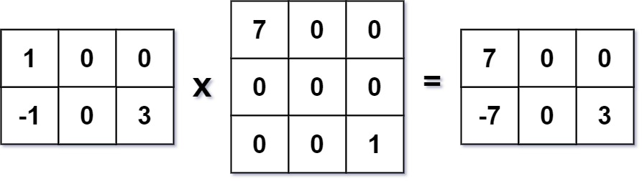

**Input:** mat1 = [[1,0,0],[-1,0,3]], mat2 = [[7,0,0],[0,0,0],[0,0,1]]

**Output:** [[7,0,0],[-7,0,3]]

**Example 2:**

**Input:** mat1 = [[0]], mat2 = [[0]]

**Output:** [[0]]

**Constraints:**

* m == mat1.length
* k == mat1[i].length == mat2.length
* n == mat2[i].length
* 1 <= m, n, k <= 100
* -100 <= mat1[i][j], mat2[i][j] <= 100